**23CSE111**

**OBJECT ORIENTED PROGRAMMING**

**LAB REPORT**



**Department of Computer Science Engineering**   **Amrita School of Computing**

**Amrita Vishwa Vidyapeetham, Amaravati Campus**

**Name: K . Yagna Suvidh**

**Roll No: 24136**

**Verified By :**

|  |  |  |  |  |
| --- | --- | --- | --- | --- |
| **S.NO** | **Experiment** | **Page No** | **Remarks** | **Signature** |
| **1** | **Installation Process of JDK** | **3-4** |  |  |
| **2** | **Simple java program for printing basic details of student** | **5** |  |  |
|  |  |  |  |  |
|  |  |  |  |  |

**INDEX**

# WEEK-1

1. **Process of Installing JDK (Java Development Kit)**

**Installing JDK (Java Development Kit):**

* 1. **Download JDK:**
* Go to the Oracle JDK download page in google and click on JDK-21 version which is Long term support (LTS) version.
* Click the download link as your operating system (Windows, macOS, or Linux).
  1. **Install JDK:**
* Once downloaded, run the installer.
* Follow the given instructions and keep clicking "Next" until it is done.
  1. **Set Environment Variables (Windows):**
* Open file explorer, then right click on This PC next select on properties then it will take you to the settings app then click on advanced system settings and then click on **Environment Variables**.
* Click on path and new under **System Variables**:

**Variable value:** The folder address where JDK is installed (like

C:\Program Files\Java\jdk-21\bin)

* Find Path under **System Variables**, click **New**, and add the path of the jdk-21(C:\Program Files\Java\jdk-21\bin)

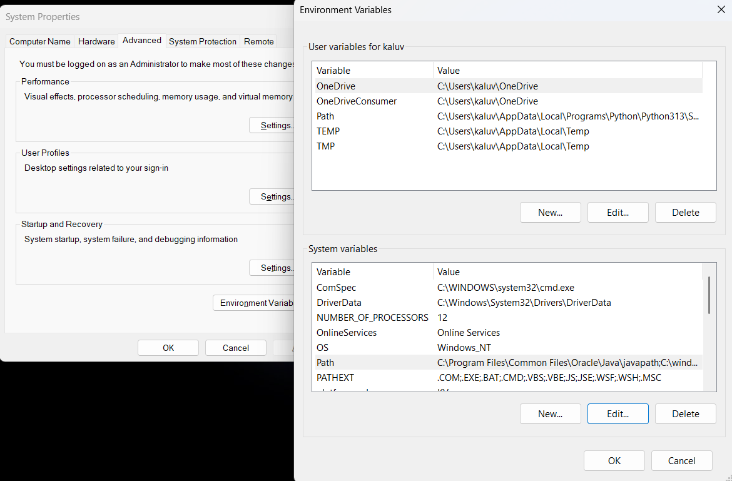

**Checking JDK Version: -**

* 1. **Open Command Prompt:**
* Presswin+R, typecmd, and press Enter.
  1. **Check Version:**
* Type java -version and press Enter.
* Type javac --version and press Enter.

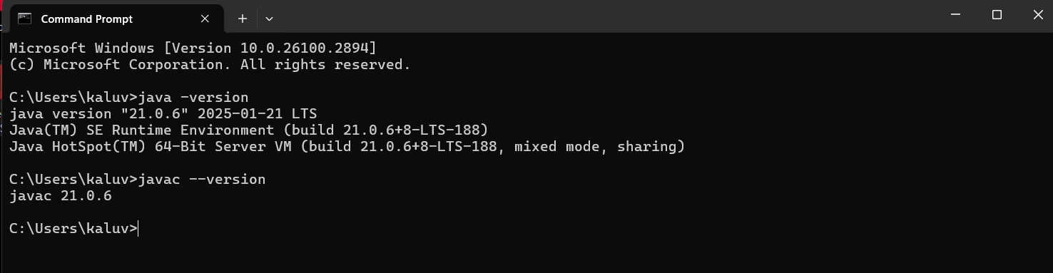

1. **Simple Java Program for printing Name, Class, Roll No, of a Student**

Write your code in Notepad and execute it in cmd prompt

**CODE: -**

class Main

{

public static void main(String[] args)

{

System.out.println("Name:K.Suvidh");

System.out.println("Class:CSE-B");

System.out.println("Roll No:24136");

}

}

**Output: -**

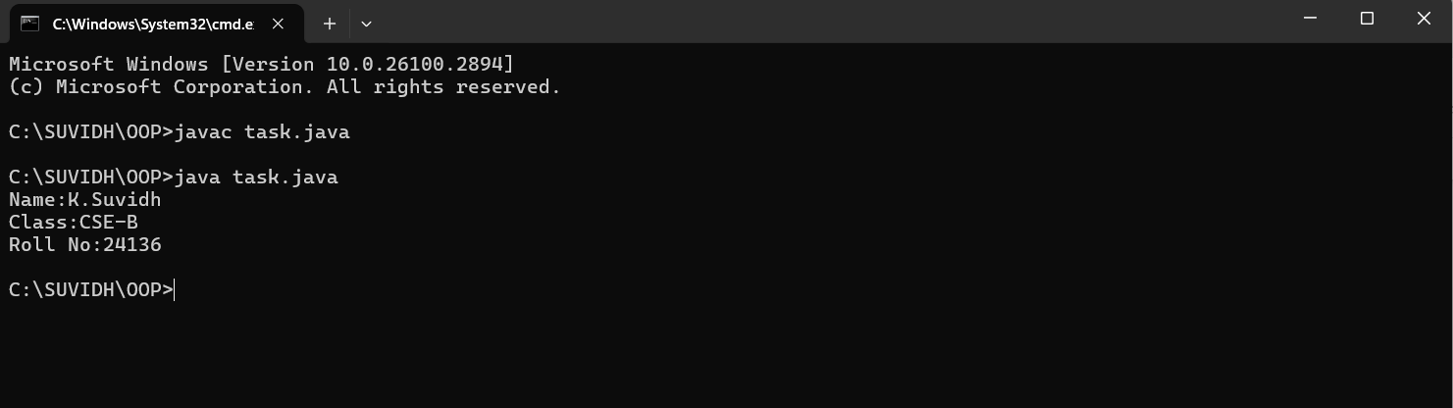

**WEEK-2**

**1) AIM:**

**Write a simple program to calculate factorial of a number and read the input from user**

**PROGRAM :**

class Test {

static int factorial(int n)

{

int res = 1, i;

for (i = 2; i <= n; i++)

res *= i;

return res;

}

public static void main(String[] args)

{

int num = 5;

System.out.println("Factorial of " + num + " is "

+ factorial(5));

}

}

**OUTPUT :**

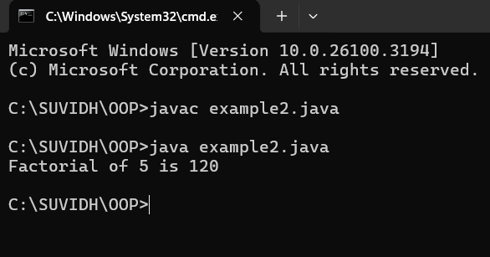

|  |  |  |  |
| --- | --- | --- | --- |
| **S.no** | **Error type** | **Reason for error** | **Rectification** |
| 1 | Undeclared variable error | Missing variable | Variable declared |
| 2 | Missing import statement | Not importing packages | Packages imported |
| 3 | Logical error | Wrong formula | Formula rectified |

**2) AIM : Simple Java Program for finding simple interest by taking input from**

**PROGRAM :**

import java.util.Scanner;

class simple {

public static void main(String[] args) {

Scanner input = new Scanner(System.in);

System.out.print("Enter p :");

int p = input.nextInt();

System.out.print("Enter t :");

int t = input.nextInt();

System.out.print("Enter r :");

int r = input.nextInt();

System.out.println("The amount is:" + (p*t*r)/100);

}

}

**OUTPUT :**

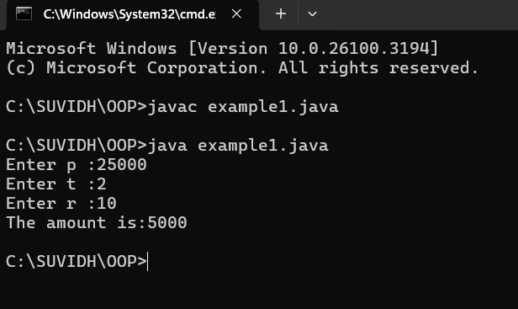

**ERROR :**

|  |  |  |  |
| --- | --- | --- | --- |
| **S.No** | **Error type** | **Reason for error** | **rectification** |
| 1 | Runtime error | Incorrect path | Copied correct path |
| 2 | Syntax error | { missing | { added |
| 3 | Logical error | Wrong formula | Formula rectified |

**3) AIM : Write a program to to calculate the fibonacii sequence and take the input from user**

**PROGRAM :**

import java.util.*;

class fibo

{

public static void main(String args[])

{

Scanner sc = new Scanner(System.in);

int num;

int f3;

int f1 = 0;

int f2 = 1;

int i = 2;

System.out.print("Enter a number:");

num = sc.nextInt();

System.out.println(f1);

System.out.println(f2);

while(i<num)

{

f3 = f1+f2;

f1 = f2;

f2 = f3;

System.out.println(f3);

i = i+1;

}

}

}

**OUTPUT :**

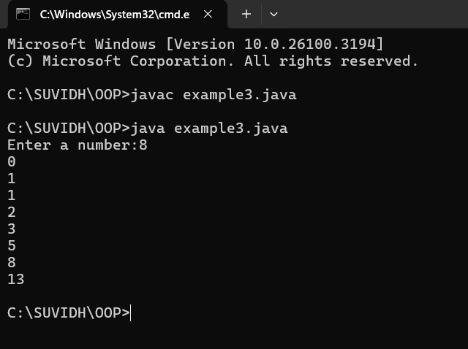

**ERROR :**

|  |  |  |  |
| --- | --- | --- | --- |
| **S.no** | **Error type** | **Reason for error** | **Rectification** |
| 1 | Logical error | Incorrect formula | Formula rectified |
| 2 | Run-time error | Incorrect path | Added correct path |

**4) AIM : Write a java program to find area of triangle using heron’s formula and area of triangle**

**PROGRAM :**

import java.util.Scanner;

class Area {

public static void main(String args[]) {

Scanner input= new Scanner(System.in);

System.out.print("Enter the length of side a: ");

double a = input.nextDouble();

System.out.print("Enter the length of side b: ");

double b = input.nextDouble();

System.out.print("Enter the length of side c: ");

double c = input.nextDouble();

double s = (a + b + c) / 2;

double area = Math.sqrt(s * (s - a) * (s - b) * (s - c));

System.out.println("The permeter of triangle is:" + s);

System.out.printf("The area of the triangle is:" + area);

}

}

**OUTPUT :**

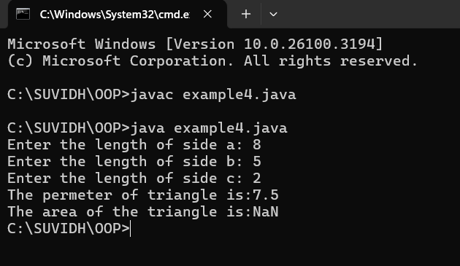

**ERRORS :**

|  |  |  |  |
| --- | --- | --- | --- |
| **S no** | **Error type** | **Reason for error** | **Rectification** |
| 1 | Syntax error | Semicolon missing | Semi colon added |
| 2 | Missing Scanner | Creating scanner input | Scanner added |

**5) AIM : Write a java program to convert temperature from Celsius to Fahrenheit**

**PROGRAM :**

class celsiustofahrenheit {

    public static void main(String[] args)

    {

        double celsius = 10.0, fahrenheit = 0.0;

        fahrenheit = (celsius * 1.8) + 32;

        System.out.println(

            " value of temperature in fahrenheit:"

            + fahrenheit);

    }

}

**OUTPUT :**

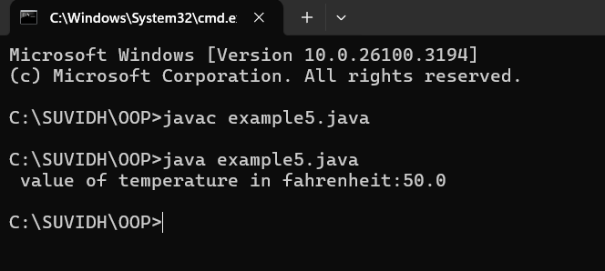

**ERRORS :**

|  |  |  |  |
| --- | --- | --- | --- |
| **S.No** | **Error type** | **Reason for error** | **Rectification** |
| 1 | Runtime error | Incorrect path selection | Correct path added |
| 2 | Logical error | Incorrect logic | Correct logic |